
European Commission - Press release
Creative Europe: Commission unveils plan to boost cultural and creative sectors
Brussels, 23 November 2011 – Thousands of people working in cinema, TV, culture, music, performing arts, heritage and related areas would benefit from increased EU support under the new 'Creative Europe' programme unveiled by the European Commission today. With a proposed budget of €1.8 billion for the period 2014-2020, it would be a much-needed boost for the cultural and creative industries, which are a major source of jobs and growth in Europe. The new programme would allocate more than €900 million in support of the cinema and audiovisual sector (area covered by current MEDIA programme) and almost € 500 million for culture. The Commission is also proposing to allocate more than €210 million for a new financial guarantee facility, which would enable small operators to access up to €1 billion in bank loans, as well as around €60 million in support of policy cooperation and fostering innovative approaches to audience building and new business models.
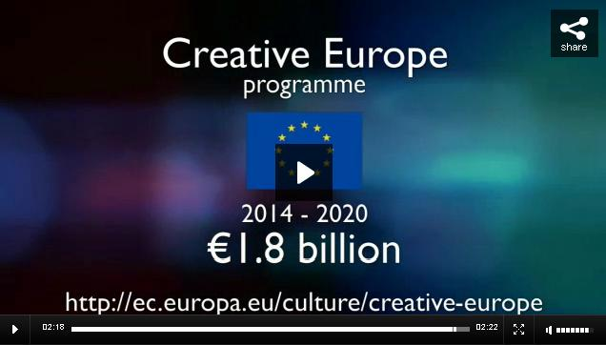
"This investment will help tens of thousands of culture and audiovisual professionals to make the most of the Single Market and to reach new audiences in Europe and beyond; without this support, it would be difficult or impossible for them to break into new markets. Creative Europe also promotes cultural and linguistic diversity, as well as contributing to our Europe 2020 objectives for jobs and sustainable growth," said Androulla Vassiliou, Commissioner for Education, Culture Multilingualism and Youth.
The Commission's Creative Europe proposal would enable:
- 300 000 artists and cultural professionals and their work to receive funding to reach new audiences beyond their home countries;
- More than 1 000 European films would receive distribution support, enabling them to be seen by audiences throughout Europe and the world;
- At least 2 500 European cinemas would receive funding enabling them to ensure that at least 50% of the films they screen are European;
- More than 5 500 books and other literary works would receive support for translation, allowing readers to enjoy them in their mother tongue;
- Thousands of cultural organisations and professionals would benefit from training to gain new skills and to strengthen their capacity to work internationally;
- At least 100 million people would be reached through the projects financed by the programme.
Background:
Creative Europe will build on the experience and success of the Culture and MEDIA programmes which have supported the cultural and audiovisual sectors for more than 20 years.
The proposed €1.8 billion budget for Creative Europe represents a 37% increase on current spending levels. In 2007-13, the MEDIA programme received €755 million, with an additional €15 million for MEDIA Mundus which supports international cooperation in the audiovisual sector. The Culture programme was allocated €400 million in the current financial framework.
The European cultural and creative sectors represent around 4.5% of European GDP and account for some 3.8% of the EU workforce (8.5 million people).
EU support will help them make the most of the opportunities created by globalisation and the digital shift. It will also enable them to overcome challenges such as market fragmentation and difficulties in accessing financing, as well as contributing to better policy-making by making it easier to share know-how and experience.
Next steps
The Creative Europe proposal is now under discussion by the Council (27 Member States) and the European Parliament who will take the final decision on the budgetary framework for 2014-2020.
For more information:
See also MEMO/11/819
http://ec.europa.eu/culture/creative-europe
http://ec.europa.eu/culture/
http://ec.europa.eu/culture/media

Contacts :
Dennis Abbott (+32 2 295 92 58)
Dina Avraam (+32 2 295 96 67)

