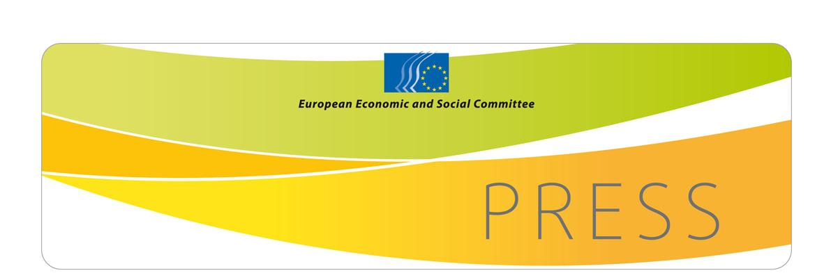  PRESS RELEASE No 79/2012 | 13 December 2012
EN

2012 EESC Civil Society Prize:
"Innovate for a sustainable Europe"
On 12 December, the European Economic and Social Committee (EESC) awarded the 2012 Civil Society Prize to Transition Network, a grassroots organisation set up in 2007 in the UK and currently active in 34 countries. More than 1000 local communities throughout Europe are engaged in transition towards a more sustainable economic and social model.

The Civil Society Prize celebrates the achievements of civil society organisations which develop projects that have a positive impact on Europeans' lives and help promote European values. In this award, the EESC supports grassroots organisations operating at European, national and local level.

The 2012 prize sought to reward innovative initiatives and projects promoting new and sustainable economic and social practices for more inclusive communities. Presenting the awards, EESC president Staffan Nilsson said that he was "impressed by the creativity and the unique character of the three winning projects" noting how proud he was of the 2012 winners, "which have social innovation at the heart of their activities and which have shown that sustainability is not only about environmental issues."

1st prize: Transition Network (UK)
Transition Network, in its own words, is an organisation which "inspires, encourages, connects, supports and trains communities as they self-organise around the transition model, creating initiatives that rebuild resilience and reduce CO₂ emissions." This UK based fast-growing network received the first prize for its REconomy project, an initiative launched in January 2011 to support a fair transition to a green economy. REconomy helps local communities to set up green businesses and to introduce eco-friendly practices in existing ones.

2nd prize: CAIS (PT)
Second prize went to CAIS, a Portuguese organisation, for its overall achievements in the 18 years it has been operating. CAIS works to promote the autonomy and empowerment of homeless people and people living in extreme poverty. Their projects range from a "street magazine" to recycling workshops and include "street football", "dry car-washing" and traditional shoe polishing. The purpose of all their initiatives is to fight social exclusion through vocational training and work. They offer disadvantaged people sustainable perspectives that go beyond charity and assistance, helping them recover the dignity to which they have a right.

3rd prize: Livstycket (SE)
Third prize went to Livstycket, an association working for the integration of immigrants into Swedish society. The association's activities are focused on teaching the Swedish language, which is a key element of effective integration, with particular attention on female immigrants. The project that earned them the award is entitled "We drink tea and learn the letter E". With this initiative, the association has taught illiterate immigrant women to read and write in a convivial atmosphere and with a mutual learning approach.

You can find more about the prize on our website:
http://www.eesc.europa.eu/civilsocietyprize

For a video clip featuring the winners and their projects, please visit:
http://www.eesc.europa.eu/?i=portal.en.events-and-activities-civil-society-prize-2012-video
For more information, please contact:
Karin Füssl, Head of the Press Unit
E-mail: karin.fussl@eesc.europa.eu
Tel.: +32 2 546 8722

