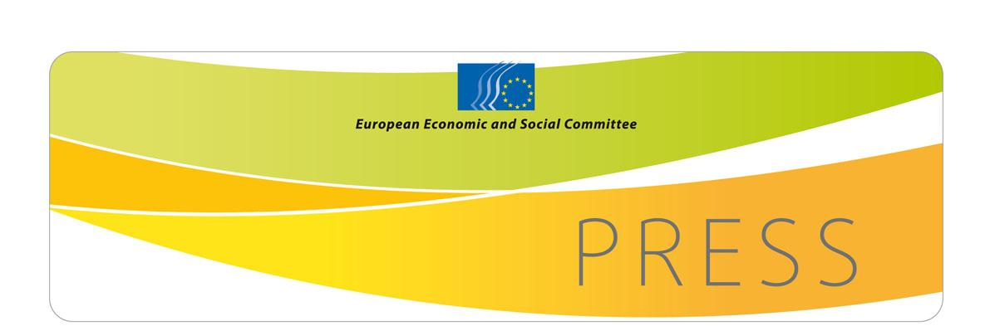  PRESS RELEASE No 32/2014 | 11 April 2014
EN

EN

EESC launches the Civil Society Prize 2014: Successful inclusion of Roma to be rewarded

The European Economic and Social Committee (EESC) is announcing the launch of its sixth EESC Civil Society Prize, worth a total of EUR 30,000. This year's prize will be awarded to initiatives aimed at Roma integration.

All civil society organisations and/or individuals who have carried out projects that improve the economic and social inclusion of Roma are invited to enter this competition.

Objective

The aim of the Civil Society Prize is to encourage civil society initiatives which make a significant contribution to promoting European identity and integration.
"Roma are part of Europe's diversity," says EESC President Malosse, "and the special skills of the Roma not only enrich Europe's culture but its society and economy as well. Their inclusion is therefore one of the EESC's policy priorities in 2014."

Initiatives promoting Roma integration should be innovative and must make a valuable contribution to the well-being of the communities in which they have been carried out.

Procedure

Entrants may only be nominated by an EESC member, national economic and social council or by a European civil society organisation or network. Any applications sent directly to the EESC will not be considered. The deadline for all applications is 15 June 2014. Prize winners will be presented with their award on 16 October. Further details and the application form are available online on the EESC's website at: www.eesc.europa.eu/civilsocietyprize

For more information, please contact:
EESC Press Unit
Tel.: +32 2 546 8141
E-mail: press@eesc.europa.eu

_______________________________________________________________________________
The European Economic and Social Committee represents the various economic and social components of organised civil society. It is an institutional consultative body established by the 1957 Treaty of Rome. Its consultative role enables its members, and hence the organisations they represent, to participate in the EU decision-making process. The Committee has 353 members from across Europe, who are appointed by the Council of the European Union.
_______________________________________________________________________________

Interested organisations/individuals may find the contact details for EESC members here.

